Title of your paper
First Author · Second Author · Third Author · Last Author

Abstract The abstract should summarize the content of the paper, indicating its aim, starting point, original contribution, and conclusions (up to 200 words).
- Introduction
This document briefly describes how to write a manuscript for the ELECTRIMACS 2026 conference.

- How to Prepare Your Paper
  - Templates
Authors are kindly invited to prepare a manuscript according to the LATEX or Word template available on the conference website:
https://www.electrimacs2026.org .
The use of LaTeX is highly recommended for manuscript preparation.
F. Author · T. Author
Department – University
address line 1
address line 2, if needed
Zip code, City, Province, Country
e-mail: fauthor@somewhere.org, tauthor@elsewhere.com

S. Author · L. Author
Institution name
address line 1
address line 2, if needed
Zip code, City, Province, Country
e-mail: ...
This is the template version 1.0 – September 2025.
  - Manuscript Information
Authors are kindly asked to prepare their manuscript according to the following specifications:
- Language: English
- Size: A4
- Two columns
- Length: from four (4) to six (6) pages.

  - Document Style and Size
The document margin and column size are summarized in Tab. 1. Font, style, and size of titles and texts are reported in Tab. 2.

Table 1 Columns and margins
Parameter | Value
Left margin | 15 mm
Right margin | 21 mm
Upper margin | 30 mm
Lower margin | 31 mm
First page upper margin | 47 mm
Blank space after the author’s line | 43 mm
Column width | 84 mm
Column separation | 6 mm
Figure width | ≤84 mm

  - Submission of papers
A camera-ready PDF manuscript must be submitted for review through the conference submission system. No other file format is accepted for this initial submission. You will find more information about the initial submission on the conference website.

Table 2 Document Style
Style | Characteristics
Paper Title | 16 pt., bold, left-aligned
Author’s names | 10 pt., bold, left-aligned
Affiliation and e-mail | 8.5 pt., left-aligned in the  footnote in column one
Section title | 10 pt., bold, left-aligned, hierarchically numbered
Subsection title | 10 pt., italic, left-aligned, hierarchically numbered
Main body text | 10 pt., justified, single-spaced
Acknowledgements section title | 8.5 pt., bold
Acknowledgements body text | 8.5 pt., justified
Figure and table title | 8.5 pt., bold
Figure and table captions | 8.5 pt., justified

  - Figure, Tables, Citations, and Cross-References

Fig. 1 Please write the caption here. If the caption is long, the text of the caption is justified.

Refer to a figure using Fig. 1, or Fig. 2. Refer to a table using Tab. 1. You can cite an item listed in the Reference section as [1] or [2,3].

  - Equations
Equations are left-aligned and numbered as shown below:
$$\left(\frac{R_{e}}{1-D}+\frac{{DT}_{s}}{C_{e}}\right)≤∆v_{pp}^{max}.$$ | (1)

Please refer to an equation using (1).

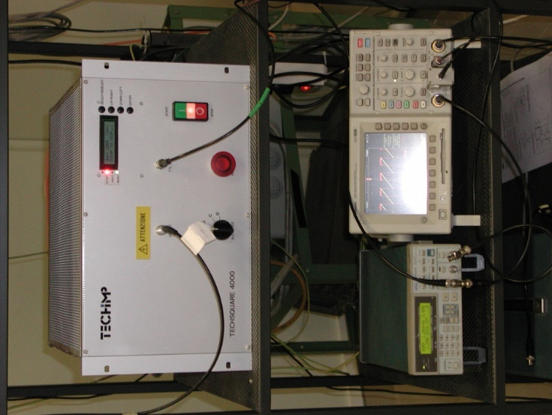
Fig. 2 Experimental setup
- Section Title
ELECTRIMACS 2026 is the International Conference of the Technical Committee ELECTRIMACS of the International Association for Mathematics and Computers in Simulation (IMACS), formerly known as IMACS TC1. The conference aims to foster scientific and professional exchange to advance research in modeling, simulation, design optimization, control implementation, numerical methods, and machine learning applied to the electrical domain.

  - Subsection Title
Applications of interest include, but are not limited to:
- electric machines and electromagnetic devices
- power electronics systems and components
- transportation systems (including space, airborne, and waterborne applications)
- microgrids and smart grids
- energy management in electrical systems
- electric and hybrid vehicles
- renewable energy systems
- energy storage technologies, including batteries, supercapacitors, and fuel cells
- wireless power transfer

- ELECTRIMACS 2026 Topics
  - Modeling, Simulation, and Identification
- Diagnostics in electrical systems
- Modeling methods and software development
- Modeling and simulation of power systems, power electronics and drives, distributed generating systems, electric machines and transformers, batteries and fuel cell systems
- Electromagnetic fields and compatibility
- Emerging electrical technologies
- Simulation methodologies for design and analysis of electromagnetic devices
- Stochastic modeling
- Thermal problems

  - System Design and Optimization
- System identification and optimization methods and theory
- Computer-aided design and optimization of power converters, protections, energy storage systems, electric machines, and power systems
- Multiphysics issues
- Power system and power converter architectures
- Methods and techniques for energy management

  - Control and Power Management
- Optimal control
- Stochastic control and filtering
- Linear and nonlinear control systems
- Linear and nonlinear programming
- Digital implementation and control
- Feedback control
- Real-time simulation methods
- Use of hardware in the loop (HIL) emulation of electrical systems
- Embedded systems
- Fuzzy logic and applications
- Genetic algorithms and evolutionary computing
- Model predictive control
- Robust control
- Sliding mode control
- Networked control systems
- Identification/diagnostic/prognostic techniques applied to electrical systems
- Power quality

  - Numerical and Data-Driven Methods, Machine Learning
- Artificial intelligence’s potential to boost electrical systems performance
- Electrical market variables pattern recognition
- Energy storage systems degradation analysis
- Renewable energy generation and electric demand forecast
- Applications in electric vehicles
- Estimation of state-of-charge and state-of-health in batteries
- Signal modeling
- Robotics and mechatronics
- Electrical system parameter identification
- Energy flows prediction
- Electrical faults forecasting

- Conclusions
Write your conclusions here.
Acknowledgments You can write your acknowledgments here, if necessary.

References
- D. Tormo, R. Vidal-Albalate, L. Idkhajine, E. Monmasson and R. Blasco-Gimenez, “Modular Multi-level Converter Hardware-in-the-Loop Simulation on low-cost System-on-Chip devices,” IECON 2018 - 44th Annual Conference of the IEEE Industrial Electronics Society, Washington DC, pp. 2827-2832, 2018.
- M. C. Di Piazza, M. Luna, G. Petrone and G. Spagnuolo, “Translation of the Single-Diode PV Model Parameters Identified by Using Explicit Formulas”, IEEE Journal of Photovoltaics, vol. 7, no. 4, pp. 1009-1016, 2017.
- S. Maniktala, Switching Power Supplies A to Z – Second Edition, Waltham, 2012.
- R. Cousseau. N. Patin. C. Forgez. E. Monmasson. L. Idkhajine, “Improved electrical model of aluminum electrolytic capacitor with anomalous diffusion for health monitoring”, Mathematics and Computers in Simulation, vol. 131, pp. 268–282, 2017.

